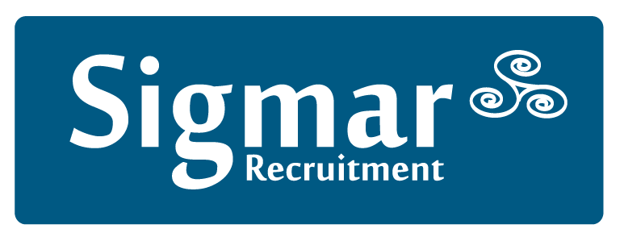

13 Hume Street, Dublin 2, D02 F861

Tel: +353 1 4744600 Fax: +353 1 4744640
Email: info@sigmar.ie Web: www.sigmar.ie

Addendum to Confirmation of Agreement

Trading Name:

Name (if different):

The Company and the Client agree to the following specific terms:

The Client acknowledges acceptance of the Terms and Conditions as detailed in the Confirmation of Agreement. These amendments to our standard terms and conditions are deemed acceptable as they are expressly authorised by a Director of Sigmar Recruitment Consultants Limited and are confirmed and agreed by the Client:

Signed on behalf of (Client):
Position: Date:
Signed on behalf of Sigmar Recruitment Consultants Limited:
Position: Date:

Office Use only: TRC CC PO VE RC________ AB+Date________________

Sigmar Recruitment Consultants Ltd, registered in Ireland no. 353252

