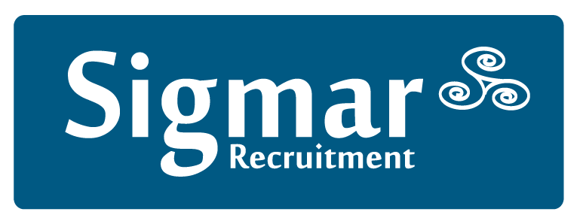
(Company No: 353252)
13 Hume Street, Dublin 2, DO2 F861
Tel: 01 4744600 Fax: 01 4744640
Email: info@sigmar.ie Web: www.sigmar.ie

DATE:
Sigmar Recruitment Consultants Limited
13 Hume Street, Dublin 2

Dear ,

We are delighted to confirm your temporary assignment with
Details are as follows:
Duration of Booking:
*Please note as advised by Client, this date is subject to change based on business demands

Working hours:
Report to:
Address:
Position:
Your hourly rate is:
Timesheet - Attached
We hope that you enjoy your assignment. Please do not hesitate to contact me if you have any queries or need assistance in the future on 01 4744600.
Kind Regards

Sigmar Recruitment
@sigmar.ie

