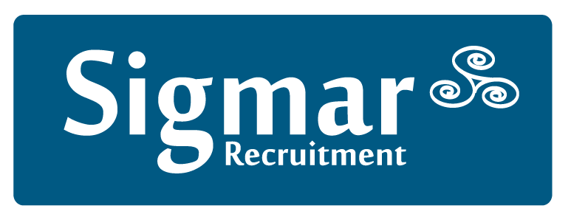

13 Hume Street, Dublin 2, D02 F861

Tel: (01) 4744600 Fax: (01) 4744640
Email: info@sigmar.ie Web: www.sigmar.ie
Accounts Dept: (01) 4744629

Addendum to Confirmation of Agreement

Trading Name:

Legal Name (if different):

The Company and the Client agree to the following specific terms:
Words and expressions defined in the Confirmation of Agreement have the same meaning in this Addendum unless the context otherwise requires.

Permanent Appointments:
The Permanent Appointment Introduction Fee is a sum equal to x% of the Gross Annual Remuneration of €x.

Contract Assignments:
The Contract Assignment fee is a sum equal to x% of the Gross Annual Remuneration of €x, pro-rated for the duration of the contract.

Temporary Assignments:
The Temporary assignment fee is an hourly bill rate of €x or an x% markup on the hourly charge incurred by the Company.

Contract Assignment to Permanent Appointment:
In addition to the contract assignment fees paid up to the date of the permanent appointment of the Candidate, an Introduction Fee of a sum equal to x% of the Gross Annual Remuneration of €x shall be payable.

Temporary Assignment to Permanent Appointment:
In addition to the temporary fees paid up to the date of the permanent appointment of the Candidate, an Introduction Fee of a sum equal to x% of the Gross Annual Remuneration of €x shall be payable.

Payment Terms Permanent Appointments:
Payment is due x days from date of Invoice. An additional interest charge in line with the ECB daily rate will be imposed on the total value of invoices remaining unpaid at the end of each month.

Payment Terms Contract Assignments:
Payment is due x days from date of Invoice. This fee shall be invoiced in full at the start of the assignment / on a monthly / quarterly basis. An additional interest charge of x% will be imposed on the total value of invoices remaining unpaid at the end of each month.

Payment Terms Temporary Assignments:
Payment is due x days from date of Invoice. This fee shall be invoiced on a weekly / monthly basis. An additional interest charge of x% will be imposed on the total value of invoices remaining unpaid at the end of each month.

The Client acknowledges acceptance of the Terms and Conditions as detailed in the Confirmation of Agreement. These amendments to our standard terms and conditions are deemed acceptable as they are expressly authorised by a Director of Sigmar Recruitment Consultants Limited and are confirmed and agreed by the Client:

Signed on behalf of (Client):
Position: Date:

Signed on behalf of Sigmar Recruitment Consultants Limited:
Position: Date:

Office Use only: TRC CC PO VE RC________ AB+Date________________

Sigmar Recruitment Consultants Ltd, registered in Ireland no. 353252

